**Employee:**

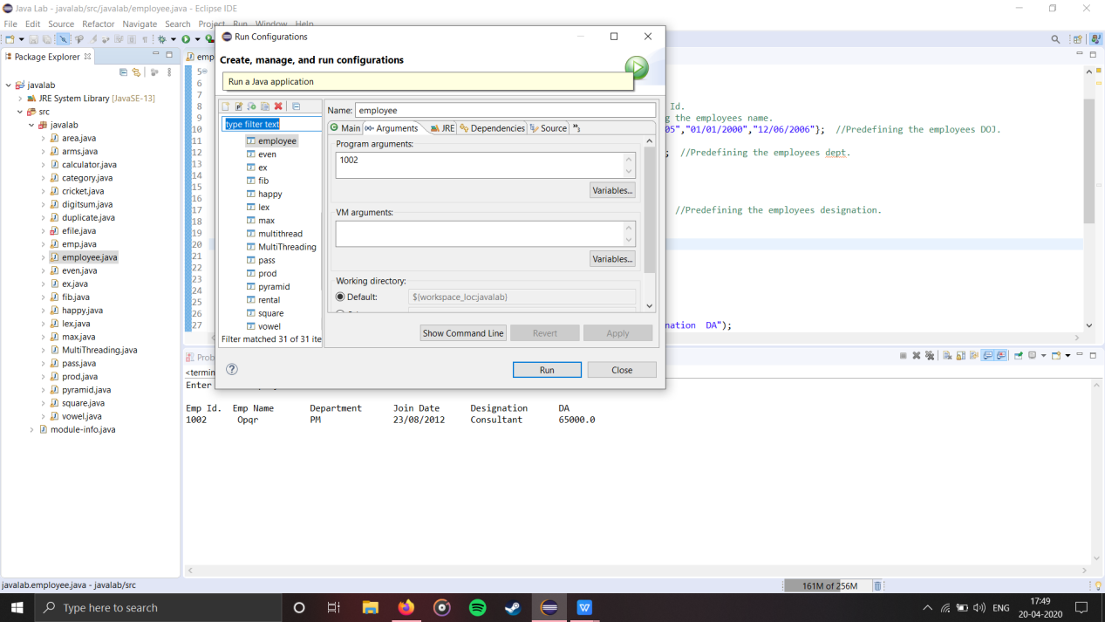

Enter Valid Employee ID :

Emp Id. Emp Name Department Join Date Designation DA

1002 Opqr PM 23/08/2012 Consultant 65000.0

**Multithreading:**

main

childthread:Thread[one,5,main]

childthread:Thread[two,5,main]

childthread:Thread[three,5,main]

one

childthread:Thread[four,5,main]

two

childthread:Thread[five,5,main]

five

First Thread is Alive? : true

Second Thread is Alive? : true

Third Thread is Alive? : true

Fourth Thread is Alive? : true

Fivth Thread is Alive? : true

waiting for Threads to complete

three

four

Sum of 1-10 : 105

Sum of 10-20 : 105

Sum of 20-30 : 119

Sum of 40-50 : 119

Sum of 30-40 : 183

Sum of 1-10 : 215

Sum of 10-20 : 215

Sum of 40-50 : 231

Sum of 20-30 : 231

Sum of 30-40 : 297

Sum of 1-10 : 330

Sum of 10-20 : 330

Sum of 40-50 : 348

Sum of 20-30 : 348

Sum of 30-40 : 416

Sum of 1-10 : 450

Sum of 10-20 : 450

Sum of 40-50 : 470

Sum of 20-30 : 470

Sum of 30-40 : 540

Sum of 10-20 : 575

Sum of 1-10 : 575

Sum of 20-30 : 597

Sum of 40-50 : 597

Sum of 30-40 : 669

Sum of 1-10 : 705

Sum of 10-20 : 705

Sum of 20-30 : 729

Sum of 40-50 : 729

Sum of 30-40 : 803

Sum of 10-20 : 840

Sum of 1-10 : 840

Sum of 40-50 : 866

Sum of 20-30 : 866

Sum of 30-40 : 942

Sum of 1-10 : 980

Sum of 10-20 : 980

Sum of 20-30 : 1008

Sum of 40-50 : 1037

Sum of 30-40 : 1086

Sum of 10-20 : 1125

Sum of 1-10 : 1125

Sum of 20-30 : 1155

Sum of 40-50 : 1155

Sum of 30-40 : 1235

Sum of 1-10 : 1275

Sum of 10-20 : 1275

Sum of 20-30 : 1275

Sum of 40-50 : 1275

Sum of 30-40 : 1275

Total sum is : 1275

First Thread is Alive? :false

Second Thread is Alive? :false

Third Thread is Alive? :false

Fourth Thread is Alive? :false

Fivth Thread is Alive? :false

Main thread is interupted

Whole process took 10 seconds

Mian thread is exiting

**Video Rental**:

%%%%%%%% VIDEO LIBRARY CENTER %%%%%%%%

1.ADD MOVIES

2.DISPLAY MOVIES

3.RENT OUT

4.COLLECT BACK

PLEASE ENTER YOUR OPTION

1

Enter the name of the movie:inception

Enter the status of the movie(True/False):true

Enter the ratings for the movie(0-5):5

Library Initialized

%%%%%%%% VIDEO LIBRARY CENTER %%%%%%%%

1.ADD MOVIES

2.DISPLAY MOVIES

3.RENT OUT

4.COLLECT BACK

PLEASE ENTER YOUR OPTION

1

Enter the name of the movie:gladiator

Enter the status of the movie(True/False):true

Enter the ratings for the movie(0-5):4

Library Initialized

%%%%%%%% VIDEO LIBRARY CENTER %%%%%%%%

1.ADD MOVIES

2.DISPLAY MOVIES

3.RENT OUT

4.COLLECT BACK

PLEASE ENTER YOUR OPTION

1

Enter the name of the movie:troy

Enter the status of the movie(True/False):false

Enter the ratings for the movie(0-5):3

Library Initialized

%%%%%%%% VIDEO LIBRARY CENTER %%%%%%%%

1.ADD MOVIES

2.DISPLAY MOVIES

3.RENT OUT

4.COLLECT BACK

PLEASE ENTER YOUR OPTION

2

Movie : inception Status : true Rating 5.0

Movie : gladiator Status : true Rating 4.0

Movie : troy Status : false Rating 3.0

%%%%%%%% VIDEO LIBRARY CENTER %%%%%%%%

1.ADD MOVIES

2.DISPLAY MOVIES

3.RENT OUT

4.COLLECT BACK

PLEASE ENTER YOUR OPTION

4

Enter the name and the ratings of the movie

troy

4

%%%%%%%% VIDEO LIBRARY CENTER %%%%%%%%

1.ADD MOVIES

2.DISPLAY MOVIES

3.RENT OUT

4.COLLECT BACK

PLEASE ENTER YOUR OPTION

2

Movie : inception Status : true Rating 5.0

Movie : gladiator Status : true Rating 4.0

Movie : troy Status : true Rating 3.5

%%%%%%%% VIDEO LIBRARY CENTER %%%%%%%%

1.ADD MOVIES

2.DISPLAY MOVIES

3.RENT OUT

4.COLLECT BACK

PLEASE ENTER YOUR OPTION

**GUI:**

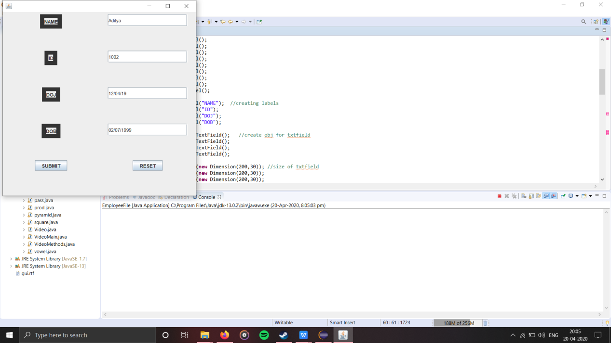

NAME : Aditya

ID : 1002

DOJ : 12/04/19

DOB : 02/07/99

**DB:**

1. Insert Emp

2. Delete Emp

3. Display Acc to Name

4. Display All

5. Exit

Enter your choice

4

Employee deatils are as follows...

Registered successfully

Connection successfull

Name : abc Age : 25 Dept :ISE Salary :25000.0

Name : pqr Age : 30 Dept :ISE Salary :30000.0

1. Insert Emp

2. Delete Emp

3. Display Acc to Name

4. Display All

5. Exit

Enter your choice

1

Enter the Employee Name :

Def

Enter the Age :

28

Enter the Dept :

CSE

Enter the Salary :

26000

Registered successfully

Connection successfull

Employee added successfully

1. Insert Emp

2. Delete Emp

3. Display Acc to Name

4. Display All

5. Exit

Enter your choice

4

Employee deatils are as follows...

Registered successfully

Connection successfull

Name : abc Age : 25 Dept :ISE Salary :25000.0

Name : pqr Age : 30 Dept :ISE Salary :30000.0

Name : Def Age : 28 Dept :CSE Salary :26000.0